

Trackmatic

Route Builder Integration Requirements Specification Document

Table of Contents

What we do 3

Types of services we offer 4

How to integrate into Route Builder? 5

How to implement this guide 5

Choose Connection 6

Types of connections 6

1. Web service request to Azure 6

2. Polling Listener 7

3. SFTP/FTP 8

4. Flat file Listener 9

5. Email Listener 10

6. Self Integrated 11

Methods of providing data 12

Posting JSON 12

Pushing XML 13

Providing CSV file 14

Field Legend 15

Datatypes 16

How to Authenticate 17

# What we do

In short, Trackmatic provides unique tailor-made software solutions to fleet operators and fleet management of On-Road Execution™ regardless of the fleet size.

We offer a holistic business solution to our clients, meeting their unique and complex requirements. We work together with them to provide insight into the finer workings of their operations, thereby increasing efficiencies and enabling greater levels of satisfaction among their customers.

Resource optimisation and service excellence are key outcomes of the solution, resulting in higher profits and driving down costs. This is where the true value of the solution is gained.

The table following summarises our solutions.

## Types of services we offer

|  |  |  |  |  |
| --- | --- | --- | --- | --- |
| On-Road ExecutionTM | Planning | Bureau | Insight | Mobility |
| Live Visibility | Backend Integration | On Road Execution Control Room | KPI Management | Turn by Turn Voice Guided Navigation |
| Historical Tracking | Route Builder | Full Audit | Planned vs Actual | Voice Calls |
| Advanced Delivery Notifications | Route Updates | DECO Management | Trending | Sign-on Glass Confirmation |
| Live Dashboards | Licensed Planning Algorithms | Voice Recordings | Driver Alignment |  |
| Risk Management | Third Party Planning Tools | Exception Based Alerts | Customised Automated Reporting |
| Speed Management | Data Integrity |  |  |

# How to integrate into Route Builder?

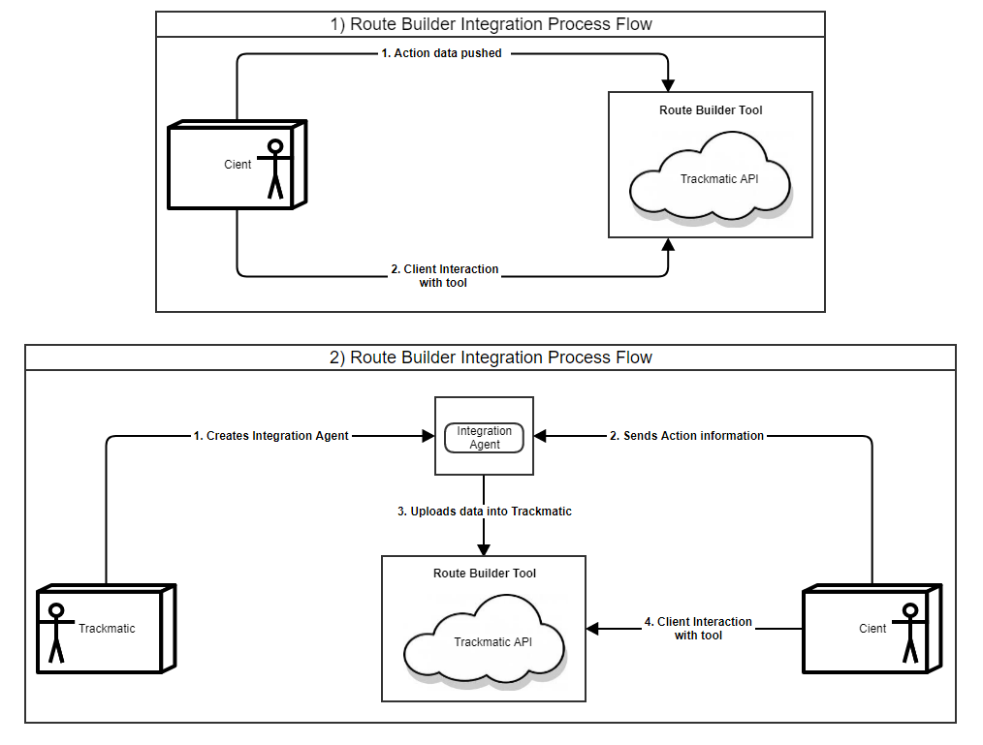Below are two diagrams which show the flow of integrating with our planning tool:

**Diagram 1 –** This depicts the flow of the processes, if you have chosen to develop your own integration with Trackmatic.

**Diagram 2 –** This depicts the flow of the processes, if Trackmatic is to develop the integration system.

If you already have integrated with us, then process 1 in diagram 2 can be omitted.

### How to implement this guide

To integrate and make use of Trackmatic’s Route Builder Tool, simply follow through the sections below: Choose Connection and Methods of providing data. To understand the required fields and their types, look at sections Datatypes and Field Legend.

## Choose Connection

### Types of connections

It is vital for the client to pay special attention in the choice you make to connect to us. The client should base their choice primarily on ease of use and efficiency to improve business feasibility as well as maintain data integrity.

There are six main methods of connecting to Trackmatic:

#### Web service request to Azure

The client presents the required data to our web service in XML or JSON. Upon receiving it, it is then mapped and uploaded into Trackmatic. Note this is a cloud hosted service.

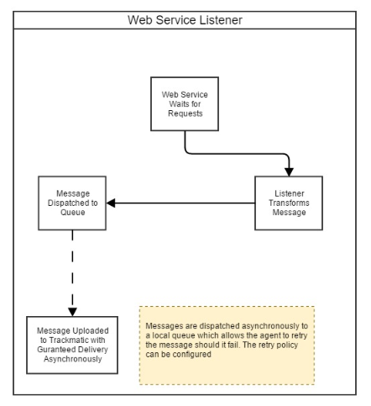

Method of providing data:

* Posting JSON

#### Polling Listener

This is installed as a service on the client’s local server or machine. It listens to a 'Trackmatic-Changes' table placed within the client’s database. This table records all the changes been made to the relevant client’s tables needed to use Trackmatic’s services. These changes in relation to the tables are then traced, picked up and updated in Trackmatic. Note this is a cloud/server hosted service.

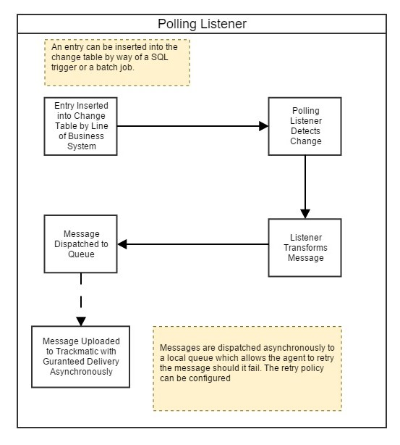

Method of providing data:

* Trackmatic’s agent will pull the fields required from the client’s database

#### SFTP/FTP

The client drops an excel extract (CSV) to the SFTP/FTP server containing all the relevant data to use Trackmatic services. The integration agent polls the directory of the SFTP/FTP for the file. If an extract is picked up, it is then read in and uploaded into Trackmatic. The client can choose to use their own SFTP/FTP server (preferable) or Trackmatics SFTP/FTP server. Note this is a cloud/server hosted service.

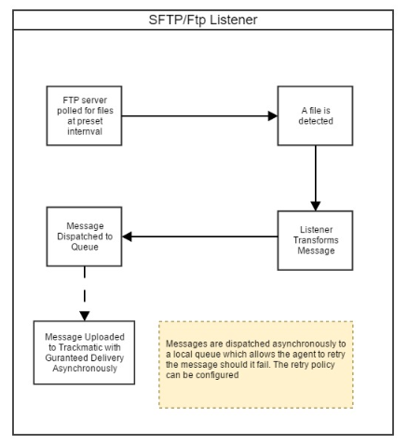

Method of providing data:

* Provide CSV file

#### Flat file Listener

Very like SFTP/FTP, the client drops an excel extract (CSV) containing all the relevant data to use Trackmatics services onto a local directory in Trackmatic’s server. The integration agent which is running on Trackmatic’s server will poll the directory for the file. If an extract is picked up, it is then read in and uploaded into Trackmatic. Note this is a local hosted service.

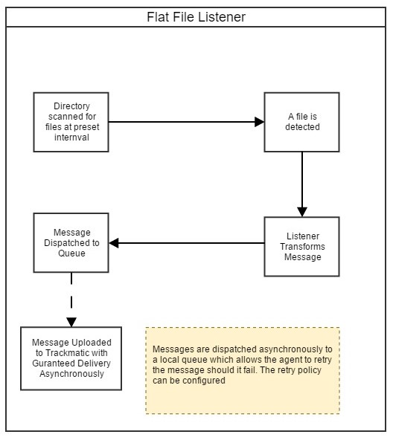

Method of providing data:

* Provide CSV file

#### Email Listener

The client emails an excel extract (CSV) containing all the relevant data to use Trackmatic’s services to an email address provided by Trackmatic. The integration agent which is running on Trackmatic’s server will then pick up this email. If an extract is picked up within the email, it will then be read in and uploaded into Trackmatic. Note this is a cloud hosted service.

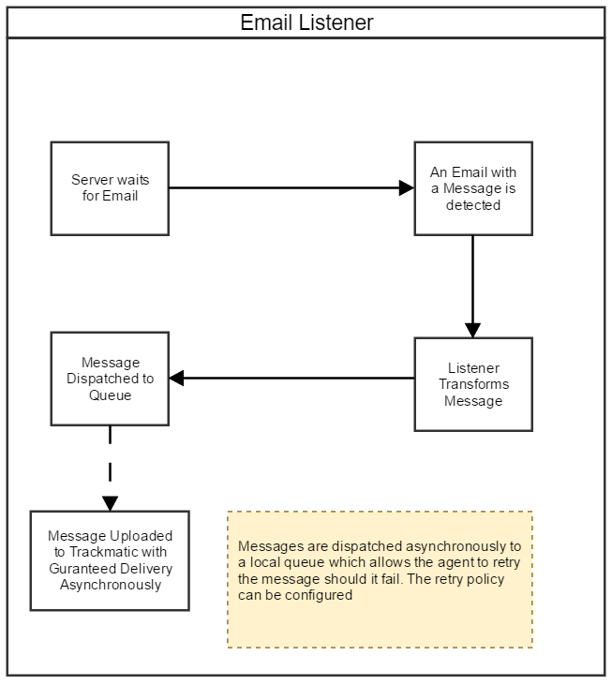

Method of providing data:

* Provide CSV file

#### Self Integrated

The client pushers all the relevant data to use Trackmatic’s services to the API directly using the credentials provided by Trackmatic. The client can send data they at their own time and this process is completely under their control.

## 

Method of providing data:

* Posting JSON

NOTE: You will be required to have Authentication to post data into Trackmatic’s API. Please see section “How to Authenticate” to see how this can be acquired.

## Methods of providing data

### Posting JSON

Skip this step and proceed to “Providing CSV file” or “Pushing XML” if you are not developing your own integration or posting data to Trackmatic’s REST service.

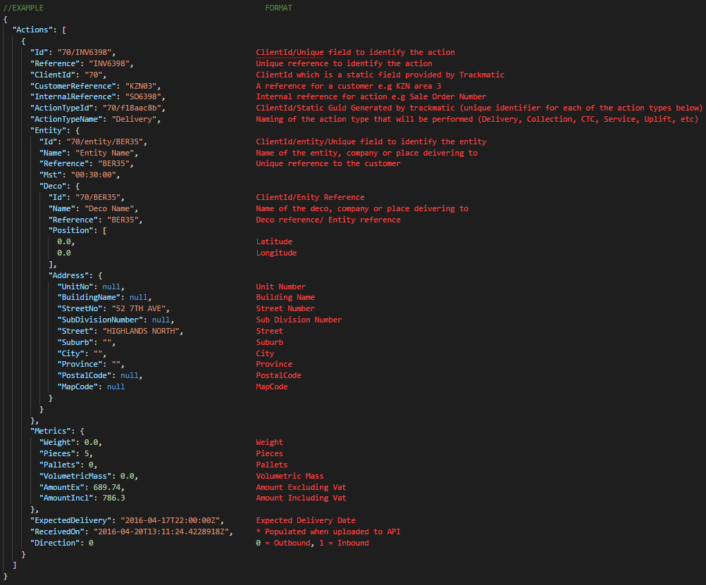If you are posting data, it should be in the JSON format shown below: Example of data to be posted is on the left while the format of data is shown on the right. Field Datatypes and Legends are shown further in their sections below.

### Pushing XML

Skip this step and proceed to “Providing CSV file” if you are not pushing data to a SOAP service of Trackmatic’s.

Below shows an example of the format of the XML to be pushed to the SOAP service.

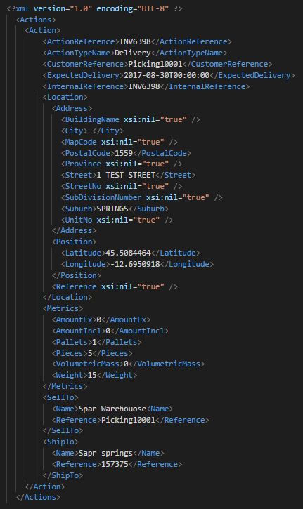

### Providing CSV file

If you are integrating using any other service than REST or SOAP service, then a CSV file should be provided with the following field

Each line can contain an Action item which is specified below:

## Field Legend



## Datatypes

## How to Authenticate

1. Upon setting up user access with Trackmatic, you will receive a USERNAME as well as a PASSWORD.
2. Make an API call to the following URL

- <https://rest.trackmatic.co.za/api/v1/core/security/authenticate>

By using the method provided below:

POST your login details with the following JSON.

{

Username: "{USERNAME}",

Password: "{PASSWORD}"

}

You will in turn receive a TOKEN.

1. Use the TOKEN received by doing the above to set a cookie:

.ASPXFORMSAUTH={TOKEN}

1. You can now start posting data in the required form which can be seen in the example “Posting JSON” in the above section.

Data should be now posted to the following URL

- https://rest.trackmatic.co.za/api/v1/planning/actions/upload